Essential Educational Qualification for the post of Primary Teacher

Sl.  No | Details | Essential Educational Qualification
1. | Name of post | Primary Teacher
2. | Educational & other qualifications required | Essential  - Senior Secondary (or equivalent) with at least 50% marks and 2 years diploma in Elementary Education (by whatever name known).  OR  Senior Secondary (or equivalent) with at least 50% marks and 4 years Bachelor of Elementary Education (B.El.Ed.)  OR  Senior Secondary (or equivalent) with at least 50% marks and 2 years diploma in Education (Special Education)  OR  Graduation with at least 50% marks and Bachelor of Education (B.Ed.)  - Pass in the Central Teacher Eligibility Test (CTET) Paper-I conducted by the CBSE in accordance with the Guidelines framed by the NCTE for the purpose.  - Competence to teach through Hindi & English medium.  Desirable:  Knowledge of Computer Applications.

Essential Educational Qualification for the post of Sports Coach

Sl.  No | Details | Essential Educational Qualification
1. | Name of post | Sports coaches - (Athletics, Taekwondo, Volleyball, Basketball etc)
2. | Educational & other qualifications required | Diploma from NIS/B.P.Ed/ M.P.Ed. from a recognized university and authenticate certificate in specialized field.
Essential Educational Qualification for the post of Yoga Instructor

Sl.  No | Details | Essential Educational Qualification
1. | Name of post | Yoga Instructor
2. | Educational & other qualifications required | Graduation & minimum 1 year Diploma in yoga from a recognized university.

Essential Educational Qualification for the post of Music / Dance Coach

Sl.  No | Details | Essential Educational Qualification
1. | Name of post | Music / Dance Coach
2. | Educational & other qualifications required | Bachelor’s Degree in Music / Dance or equivalent from a recognized University.

Essential Educational Qualification for the post of Counsellor

Sl.  No | Details | Essential Educational Qualification
1. | Name of post | Counsellor
2. | Educational & other qualifications required | BA/BSc(Psychology) from a recognized university and Diploma in Guidance and Counselling.

Essential Educational Qualification for the post of Nurse

Sl.  No | Details | Essential Educational Qualification
1. | Name of post | Nurse
2. | Educational & other qualifications required | Three Years Diploma/Degree in Nursing with valid registration. (BLS[Basic Life Support] course at least once in two years).

Essential Educational Qualification for the post of Data Entry Operator (DEO)

Sl.  No | Details | Essential Educational Qualification
1. | Name of post | DEO
2. | Educational & other qualifications required | Class XII – Computer knowledge

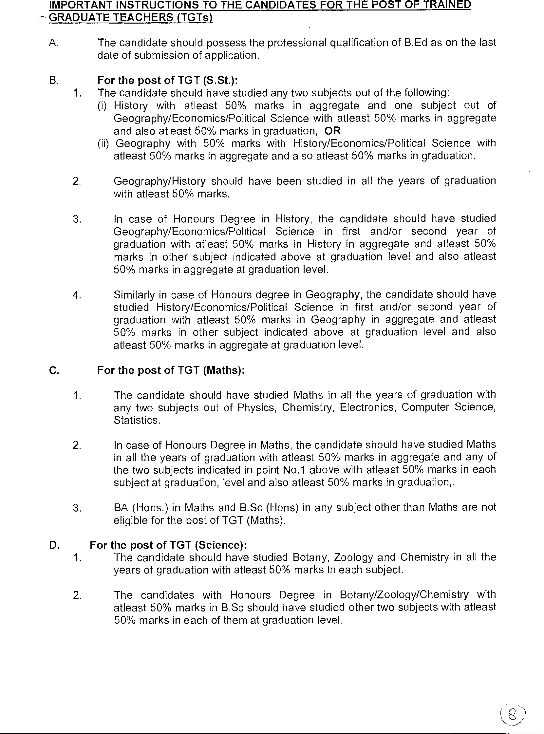

E. For the posts of TGT (English/Hindi/ Sanskrit):
The candidate should have studied English /Hindi/ Sanskrit in all the years of graduation with at least 50% marks in English/Hindi/ Sanskrit for the posts of TGT (English/Hindi/ Sanskrit) respectively and also at least 50% marks in graduation.

*******************************************************************************

